Task 1.1:
Linda’s porch and hall light
System Overview:
This project uses an Arduino micro controller to control an automatic lighting system for Linda’s house.
When the button is pressed:
- Both lights turn on
- Porch light waits for 30 seconds and turns off
- Hall light waits for 60 seconds and turns off
The system aims to improve safety and visibility when she returns home at night.
Program Overview:
Global variables:
- Pins
  - Button, Input
  - Led1, Output
  - Led2, Output
- Timing variables
  - porchStart
  - hallwayStart
- State variables
  - porchOn
  - hallwayOn
These variables allow the program to:
- Track whether each light is currently ON or OFF
- Record the time at which each light was activated
- Control both lights independently
Setup():
The setup function initializes serial communication and configures the pin mode. Ensures both LEDs start in the off state.

Lightcontrol():
This function reads the button state and detects when the button is in pressed.
Turns both lights on after button press.
Stores the LED activation time using millis() and checks if 30s or 60s has passed and turns lights off after timer has passed.
Loop()
Only calls the lightcontrol() function

Circuit Overview:
Components:
- Arduino Microcontroller
- Push button
- 2 LEDs (representing porch & hallway)
- 2 current-limiting resistors (220Ω)
- Optional pull-down resistor (if using INPUT mode)
Diagram:
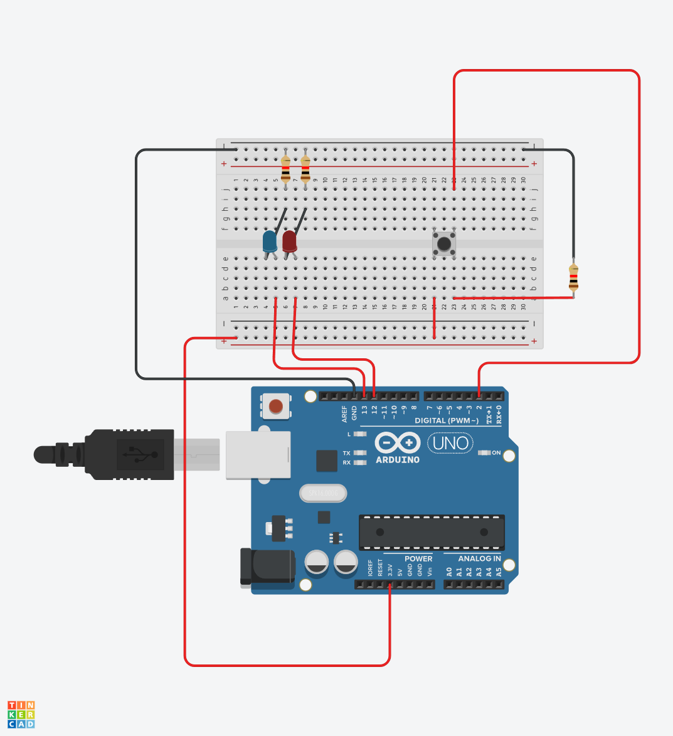

Modular code:
This project utilised modular programming was used by separating the lighting control logic into its own dedicated function.
So instead of having everything inside the main loop is broken into
- Setup() – hardware initialization
- Lightcontrol() – lights behaviour and timing logic
- Loop() – calls control modules
This makes the code logic more intuitive and easier to understand what’s happening and when. This will be very useful for future upgrades using more larger, complex systems.

Design flaws:
This solution still requires a physical button, and the lights will turn off at a fixed time regardless of where you are, thus if your still outside you could end up in the dark.
The mechanical button may bounce causing unintended triggering and it can still turn on during the day when it isn’t necessary causing energy wastage

Design fixes and potential modules:
- use motion sensors
  - replace the mechanical button senor with PIR motion sensors creating a PIR switch module
- ambient light sensors
  - use a light sensor to read light levels and only allow the lights to turn on after dark. Add a module to read light levels
- digital button
  - add a digital button connected to Wi-Fi to allow remote control from anywhere. Create a Wi-Fi control module

GitHub link: https://github.com/charlieM044/SIT210
Video link: https://youtube.com/shorts/Ma6ZtcbaLU4?si=XTwYXT8wsZ5EpBPJ

